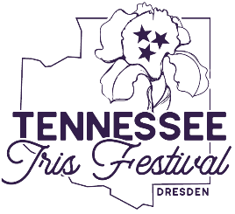

IRIS FESTIVAL

PARADE ENTRY FORM

Saturday, May 6th, 2023, at 10 a.m.
Parade line-up will start on Gaylord St behind, McWherter Civic Center at 8:30 a.m
Judging will Start at 9 a.m.
Entry fee: $5 for all entries
Please make checks payable to Simmons Bank
Please fill in each blank and be specific. Separate forms must be completed for each entry. Entries will be judged based on: Most Beautiful, Most Original, Best Theme. First place ribbons will be awarded in each category.
Is your entry a float? (Y/N)
Is your entry a costume character(s)? (Y/N)
Is your entry a car or truck? (Y/N)
Other? (Y/N)) Explain

Name of entry/sponsor:

Contact Person:

Contact Phone #:

Address of Contact:

Description of Entry:

IMPORTANT: Please list contact person and phone number to confirm entry. Line up information will be provided once your entry has been confirmed. Anyone driving a motorized vehicle (car, ATV, motorcycle, etc.) must be at least 16 years of age and have a valid driver's license.

Deadline to enter is Tuesday, May 2nd, 2023. Mail forms to Simmons Bank C/O Emily Vickers, PO Box 169, Dresden, TN 38225 or turn in forms at City Hall in Dresden.
For more information please contact 731-364-3131

